|  |  |
| --- | --- |
|  | **Qatar University**  **College of Engineering**  **Department of Computer Science and Engineering** |

Senior Project Report

**ParQU - Parking System Using Cloud Computing Based on IoT**

**Project Group Members:**  
Amal Khaled Haidarah (201302862)

Alaa Mousa Mousa (201305148)  
Ghareisa Mohammed Al-Kuwari (201402464)

**Supervisor**: Dr. Abdulaziz Al-Ali

**2019**

This project report is submitted to the Department of Computer Science and Engineering of Qatar University in partial fulfillment of the requirements of the Senior Project course.

# Declaration

This report has not been submitted for any other degree at this or any other University. It is solely the work of us except where cited in the text or the Acknowledgements page. It describes work carried out by us for the capstone design project. We are aware of the university’s policy on plagiarism and the associated penalties and we declare that this report is the product of our own work.

Student: Amal Khaled Haidarah Date:

Signature:

Student: Alaa Mousa Mousa Date:

Signature:

Student: Ghareisa Mohammed Al-Kuwari Date:

Signature:

# Abstract

Qatar University became one of the most crowded places in Qatar, which with time raised a huge parking problem that led to a chaotic parking experience in the university. Faculty, staff and students complain about the negative effects that the lack of parking causes, such as not finding a vacant parking spot easily, which in turn makes them waste time and get late for their lectures. In the hopes of solving this issue, we are planning to create a parking system based on the Internet of Things (IoT) concept. IoT is a network consisting of devices, machines or objects that are able to communicate and transfer data without the need of a human-to-human or human-to-computer interaction.

The system will give the users the ability to reserve a parking spot with the requirement of subscribing into our system. Also, the system gives the service of viewing the availability of a parking spot without the need of a subscription. The parking system involves an Android mobile application, a website and a hardware prototype to be installed in the parking area. The hardware prototype consists of sensors such as Ultrasonic sensor and RFID (Radio Frequency Identification) for car detection and an embedded system to collect data from these sensors and communicate that information to the cloud. The on-board application and website exposes the functionalities of the system along with a cloud database for data storage.

# Acknowledgment

Our project “ParQU - Parking System Using Cloud Computing Based on IoT” gave us a huge amount of experience and knowledge.

First and foremost, we would like to sincerely thank our supervisor Dr. Abdulaziz Al-Ali for his guidance, patience and motivation as well as providing us with the needed comments and suggestions that helped us improve and give our best work.

We would also like to thank our families, friends and colleagues who encouraged us to continue with the project.

Contents

Declaration ii

Abstract iii

Acknowledgment iv

List of Figures vi

List of Tables vi

1. Introduction and Motivation 7

1.1. Problem statement 7

1.2. Project significance 11

1.3. Project objectives 11

2. Background and related work 11

2.1. Background 11

2.2. Related work 12

3. Requirements analysis 18

3.1. Software development process 19

3.2. Functional requirements 20

3.3. Non-functional requirements 22

3.4. Assumptions 23

3.5. Ethics 23

References 26

# List of Figures

Figure ‎1‑1: Statistics from Survey 7

Figure ‎1‑2: Tweet from Twitter about the parking problem 8

Figure ‎1‑3: Tweet from Twitter about the parking problem 8

Figure ‎1‑4: Tweet from Twitter about the parking problem 8

Figure ‎1‑5: Tweet from Twitter about the parking problem 8

Figure ‎1‑6: Article from Al-Sharq Newspaper 8

Figure ‎1‑7: Headline from Al-Raya Newspaper 8

Figure ‎1‑8: Headline from Al-Arab Newspaper 9

Figure ‎1‑9: Headline from Al-Arab Newspaper 9

Figure ‎1‑10: Headline from Al-Arab Newspaper 9

Figure ‎1‑11: Headline from Al-Watan Newspaper 9

Figure ‎1‑12: Statistics from Survey 10

Figure ‎1‑13: Vehicles in Qatar University parked illegally 10

Figure ‎1‑14: Vehicles in Qatar University parked illegally 10

Figure ‎2‑1: A Secure Parking Reservation System Using GSM Technology – System architecture 13

Figure ‎2‑2: System Initialization 13

Figure ‎2‑3: Image capture from camera 13

Figure ‎2‑4: Binary image 14

Figure ‎2‑5: Image after Tracing object boundaries 14

Figure ‎2‑6: Detected parking spot 14

Figure ‎2‑7: GUI Display on PC or laptop 15

Figure ‎2‑8: Hardware architecture of the system 15

Figure ‎2‑9: Hardware architecture of the system 16

Figure ‎2‑10: Working process of the system 17

Figure ‎3‑1: Scrum process overview 19

Figure ‎3‑2: Scrum cycle 19

Figure ‎3‑3: Use case diagram 21

# List of Tables

Table ‎2‑1: Related work comparison 18

Table ‎3‑1: Actor type and descriptions 21

Table ‎3‑2: Use cases and descriptions 21

Table ‎3‑3: Technical design constraints 22

Table ‎3‑4: Practical design constraints 22

Table ‎3‑5: Standard types and descriptions 23

Table ‎3‑6: IEEE and ACM code of ethics 23

# Introduction and Motivation

Wherever a person goes to in a country with high population density areas, a parking issue will most likely be present. There is no difference in the case of Qatar as it is becoming more density populated, and one crowded place in the country is Qatar University (QU). Students in QU have started becoming more independent in their everyday life, and that involves driving a car. The number of students at QU owning a car is increasing drastically each year, not to mention the increasing number of students QU accepts each year, both of which have led to the demand for more parking spots. As Qatar University students, we are personally motivated to come up with a solution to this problem.

## Problem statement

Over the past few years, the number of students in Qatar University (QU) has been steadily rising each year, which in turn has led to an increase in the number of vehicles arriving on the campus. According to the Ministry of Education statistics from 2012, the number of students attending QU exceeded ten thousand students [1] and is only increasing with each passing year. Likewise, the number of staff and faculty that need parking for their vehicles has also increased. Today, the number of students at Qatar University has reached more than 20,000 [2]. As a result, there has been a rapid increase in the number of people and vehicles on campus, and with the limited available parking spaces, parking problems are bound to exist. An online survey was shared with Qatar University students to assess the severity of the parking problem. As shown in Figure 1-1, 94.3% of the survey respondents believed that there is a real problem in finding a vacant parking spot inside the campus.



Figure ‎1‑1: Statistics from Survey

Frustrated students have taken to social media to air their criticism on the ongoing crisis of parking areas at Qatar University [3]. Students have circulated comments, pictures, and videos that represent their daily suffering due to the lack of parking spaces allocated to them in the university. Many sarcastic and critical tweets have discussed this issue, as displayed in Figures 1-2 until 1-5.



Figure ‎1‑2: Tweet from Twitter about the parking problem

Figure ‎1‑3: Tweet from Twitter about the parking problem





Figure ‎1‑5: Tweet from Twitter about the parking problem

Figure ‎1‑4: Tweet from Twitter about the parking problem

The problem has transcended student conversation to become the talk of the media in Qatar. Figures 1-6 up to 1-11 show headlines from prominent local newspapers (Al-Raya, Al-Watan, Al-Arab and Al-Sharq) that discuss the parking problem at Qatar University and its impact [4]. The articles made mention of the fact that the effects of this problem were not only limited to students and staff but also impacted the university’s visiting guests who come for events, ceremonies, seminars or conferences.

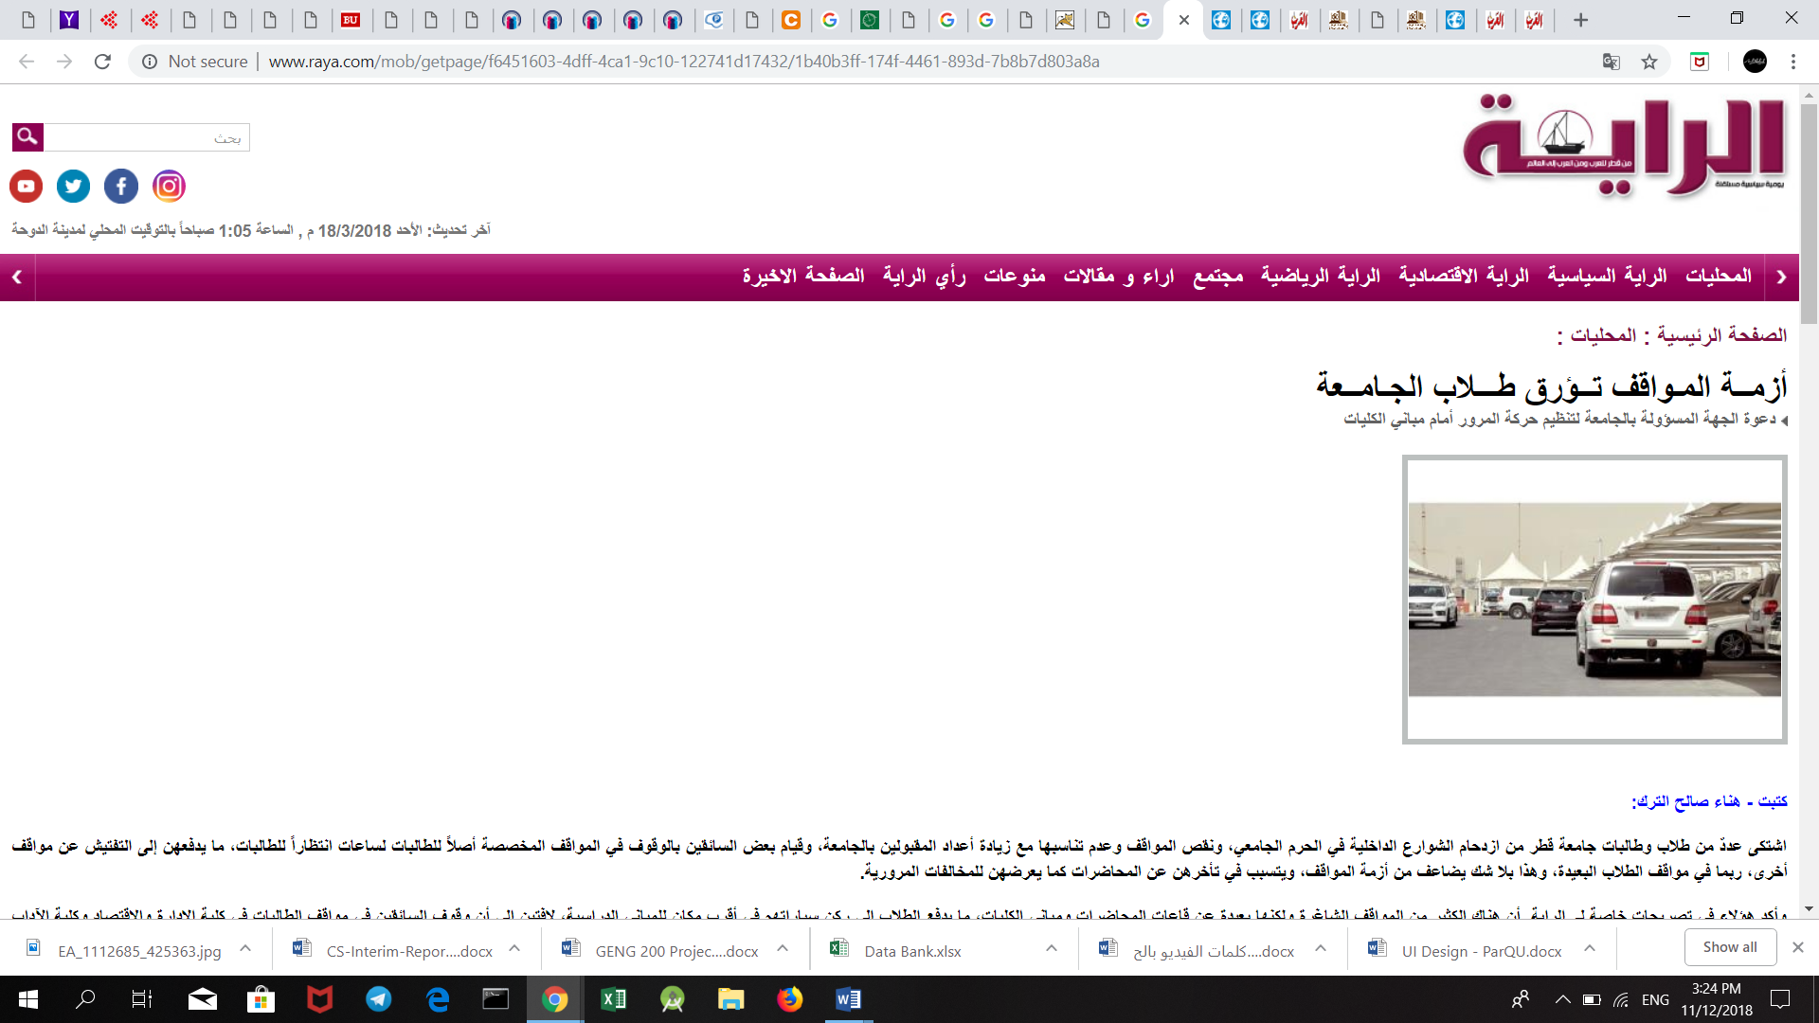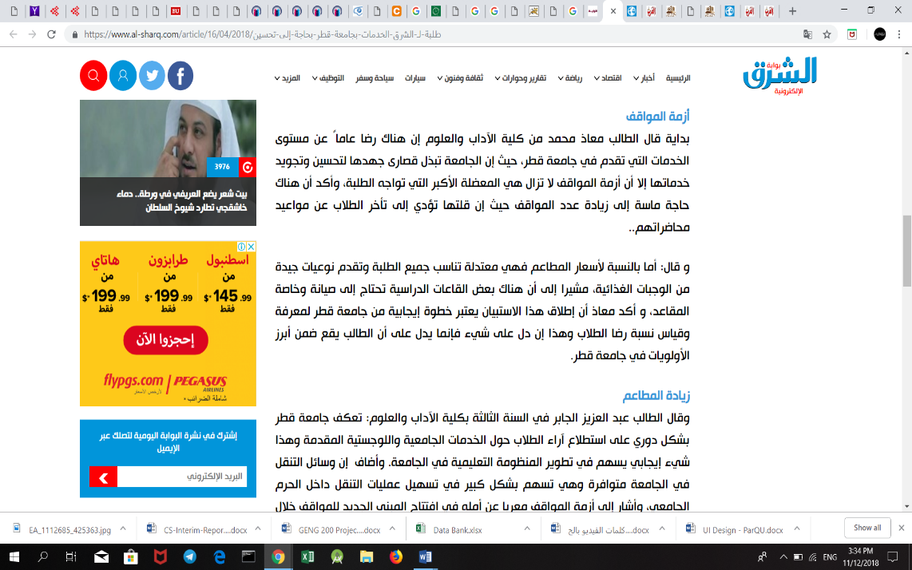

Figure ‎1‑6: Article from Al-Sharq Newspaper

Figure ‎1‑7: Headline from Al-Raya Newspaper



Figure ‎1‑8: Headline from Al-Arab Newspaper

Figure ‎1‑9: Headline from Al-Arab Newspaper



Figure ‎1‑10: Headline from Al-Arab Newspaper

Figure ‎1‑11: Headline from Al-Watan Newspaper

**Impact**

People looking for an empty parking spot constitutes one of the most significant causes of congestion, and wastes the time of students and staff. As shown in Figure 1-12, more than 60% of the students who responded to our survey reported that they take more than 15 minutes to find a vacant parking spot. To a student, 15 minutes late could mean being late for an exam or a quiz. Also, if the professor takes attendance at the start of the lecture, the student may be counted as absent. Further, Qatar University follows an attendance policy that states that a student automatically fails a course if he/she is absent for more than 25% of the class sessions. Hence, if the problem continues, it is possible that students will exceed the allowable absences and fail one of their courses. As a result, many students have declared that they are forced to come to the university early so that they can get a parking slot for their cars [5].



Figure ‎1‑12: Statistics from Survey

Even though people rarely notice or discuss the environmental impact, the parking problem creates environmental effects as it causes vehicles to consume more fuel while driving around to search for parking spots. This increase in fuel consumption wastes the vehicle owner’s money and leads to more CO2 emissions.

Additionally, hurried drivers are forced to park in illegal parking places which in turn leads to an increase in the number of traffic violations and accidents inside the campus. Figures 1-13 and 1-14 below show examples of illegal parking where cars are parked over sidewalks and on the grass field.



Figure ‎1‑13: Vehicles in Qatar University parked illegally

Figure ‎1‑14: Vehicles in Qatar University parked illegally

In the end, the university’s reputation is negatively affected by this situation, because it is the first thing that guests see when visiting and that students and staff notice when they start their day.

## Project significance

A parking system is needed to organize and utilize the parking area resources. An adequate parking system would be able to guide the vehicle owners at the university in such a way as to reduce traffic overcrowding by suggesting different routes along the campus roads. Such a system could reduce the vehicle owner’s search time significantly by providing such information. As a result, traffic congestion would decrease and the university would be able to fine vehicle owners when they park illegally.

A smart parking system would not only be beneficial for anyone entering the campus of Qatar University but would also be considered valuable for the environment [6][7]. The environment is more protected by the decreased CO2 emissions from cars that would reduce the level of pollution [6]. Also, for the security and other monitoring staff, the data gathered via the implementation of the parking system could be used to predict future parking patterns. Strategies for setting fines and parking fees could also be manipulated based on the information gained to increase the university’s profit.

## Project objectives

1. To design and implement a system that can manage parking areas.

2. To use sensors (Ultrasonic Sensor and RFID Reader) to collect data.

3. To use microcontroller boards (Arduino) to receive data from used sensors and send it to a database (Firebase) for storage.

4. To design an Android application and a website.

# Background and related work

In this section, we introduce the parking problem background and some related existing solutions that aim to organize the parking spaces

## Background

Finding a parking spot may seem like a superficial problem or an individual problem, but it is, in fact, a problem that causes significant issues in the day to day life of people. In metropolitan areas worldwide, having a parking area is increasingly important, and a substantial amount of land and buildings are set aside to accommodate the growing demand for parking spaces. For instance, in Australia, parking areas hold great importance especially in Brisbane, Sydney, and Melbourne where they have a vast number of parking spaces ranging from 25,633 to 41,687 [8]. Furthermore, estimates show that around 30,000 square kilometers of land in Europe and 27,000 square kilometers in the US are devoted to parking spaces [9].

Moreover, parking can be very time consuming and costly. Hence, it comes as no surprise that “The U.S. economy bears the brunt of parking pain as 40% of drivers say they have avoided driving to shops due to parking challenges.” [10]. According to a study from car service company Inrix, Americans spend an average of 17 hours per year searching for a vacant parking spot, and this leads to a loss of $345 per driver in wasted time and fuel. Similarly, drivers in the UK spend an average of 44 hours a year looking for empty parking, with an estimated total loss of £733.

Contrary to the popular belief that generous parking allocations benefit users, the opposite can happen when there is an exaggeration in parking allocations. A big parking lot prolongs transportation time and is a waste of useable land. These effects -along with recent land-use, socioeconomic and technological trends- are prompting towns to begin asking some critical questions about how to solve the parking problem smartly and cost-effectively. For this reason, there have been many attempts to provide smart parking systems as a solution, with each having its different approach as shown in the Related Work section

## Related work

Several studies conducted and presented in previous literature related to our project have helped us in the development and implementation of our design.

**A Secure Parking Reservation System Using GSM Technology**

[11] have used GSM technology to propose a secure and smart reservation system for parking areas. The system consists of two major modules which are security reservation module and parking lot monitoring.

Secure Reservation Module

The main idea is that the user has to send an SMS message using GSM (Global System for Mobile communications) to a Visual Basic (VB) application in a laptop/PC. The VB then processes the requested data and checks the available spot. They use open APIs in VB to handle SMS messages. If the requested parking lot is available, the user will receive a confirmed message that has the location for the spot and password. Otherwise, it will receive a reject message.

Parking Lot Monitoring Module

The primary aim of this module is to show the status of the parking spots using Parking Layout Animation program through Visual Basic application in a laptop/PC. Their program displays the status of each parking spot through colors. Green for *empty*, yellow for *reserved*, and red for *occupied*. Initially, the state of all parking spots is *empty*. The status will change to *reserved* if the user successfully reserves a parking spot. When the user arrives at the entrance gate, he enters the password and then the controller will verify this password. If the password is valid, the gate will open, and the Parking Layout module will update the spot status to *occupied*.

By using this approach, the user will be charged by the telecommunication company to send SMS messages. Also, GSM is prone to be easily congested in crowded areas [12]. In their approach, all information is stored locally on one computer which is inefficient as the computer memory will eventually be too full to save any more information from the system. Also, if the computer is somehow damaged, all the data will be lost.

Figure ‎2‑1: A Secure Parking Reservation System Using GSM Technology – System architecture

**Intelligent Parking Space Detection System Based on Image Processing**

[13] used an image processing technique to detect if the parking lot is empty or not. The proposed solution is carried out in 5 steps as follows:

1- System Initialization:

In the beginning, a rounded brown image is drawn at each parking manually to determine their positions.

Figure ‎2‑2: System Initialization

2- Image Acquisition:

The camera captures an RGB image for the car park scene and sends it to the processing unit that runs in MATLAB.

Figure ‎2‑3: Image capture from camera

3- Image Segmentation:

MATLAB converts the RGB Image to a grey scale image. Then thresholding technique on the grey scale image is applied to create a binary image. This technique helps in separating the objects from the background.

Figure ‎2‑4: Binary image

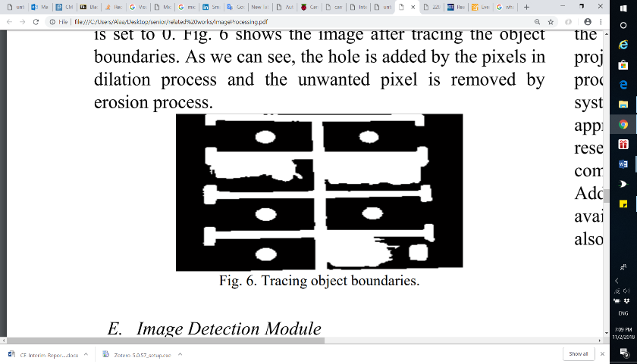4- Image Enhancement:

The morphology functions such as dilation, erosion, opening, and closing are used to remove noise from the binary image as well as to trace the exterior boundaries of the object.

Figure ‎2‑5: Image after Tracing object boundaries

5- Image Detection Module:

The system detects if the parking lot is empty or not by identifying the rounded brown image at every spot.

Figure ‎2‑6: Detected parking spot

This approach may not function well in extreme weather conditions as the camera might be damaged. Also, placing the camera in a suitable location such that all parking areas are visible, and there are no objects that might obstruct the camera's vision is essential for the camera to work as planned.

**Monitoring Parking Space Availability via Zigbee Technology**

In [14], the system’s primary function is to allow its users to view the available parking spots through a screen at the gates of a parking area using Zigbee wireless technology for communication and digital infrared sensors for vehicle detection.

The system consists of two main modules:

Parking Lot Vacancy Monitoring Module

The module comprises of digital infrared sensors, Zigbee module, PIC microcontroller 18F4550, and an LCD. This module is used to detect the available parking spots. A digital infrared sensor is implemented on top of each parking spot to detect the existence of a vehicle such that each sensor is used to monitor one parking spot. Infrared sensors work with the reflected light wave and consist of an IR transmitter and an IR receiver. The IR transmitter emits infrared light, which gets reflected when it meets a reflecting surface (e.g., white color). The IR receiver then detects the reflected light and calculates the distance between the sensor and the object. The infrared sensor interfaces with a PIC microcontroller, which also interfaces with a Zigbee module for wireless transmission. When the sensor senses a vehicle in the parking spot, it informs the microcontroller, and then the microcontroller notifies the master module through the Zigbee module.

Master Module

The master module consists of a GUI display shown through a PC or a laptop, and a Zigbee module. The GUI display, shown in Figure 2-7, allows the user to see precisely which parking spot is available. Whenever the Zigbee module receives data about a particular parking spot from the Parking Lot Vacancy Monitoring module, it informs the PC/laptop that it is interfaced with to update the status of a parking spot.

However, this system has several disadvantages. The infrared sensor is hugely dependent on light as brighter surfaces are more accessible for detection than darker surfaces. Hence, changing light conditions could give wrong outputs. Also, the system does not have a mobile application for a remote user interface and restrict its users to a GUI interface at the gates of the parking lot.

Figure 2-8 shows the hardware architecture of the system.

Figure ‎2‑7: GUI Display on PC or laptop



Figure ‎2‑8: Hardware architecture of the system

**Smart Parking System (SPS) Architecture Using Ultrasonic Detector**

[15] is a smart parking system for multilevel parking lots which uses ultrasonic sensors to detect the occupancy of a parking space and shows it to the user at the parking area using display boards. The display boards display the number of available parking spots, and they are implemented indoors, at the entrance to each level and the end of each aisle of the parking lot, and outdoors, at the entry and exit of the parking lot. Furthermore, an ultrasonic sensor is installed on the ceiling of a parking spot and is used to detect cars on that spot only. LEDs with different colors accompany each ultrasonic sensor to inform the user of the parking spot status (reserved, occupied, vacant or handicapped). Moreover, the system includes a monitoring software and line detection system to detect improper parking. The line detection system is implemented by adding two additional ultrasonic sensors horizontally on the right and left of each parking spot such that they face the parking spot lines. Whenever a car goes over the detection line, an alarm will go off until the vehicle has moved out of the line.

Figure ‎2‑9: Hardware architecture of the system

Figure 2-9 shows the overall hardware architecture of the system. The system consists of ultrasonic sensors, LED indicators, indoor display boards, outdoor display boards, zone control units (ZCU), a central control unit (CCU), network switch, telephone cable, and management software. When the ultrasonic sensor detects a change in the status of a parking area, it transmits the status to the zone control unit (ZCU) through a telephone cable. The ZCU then forwards the information to the central control unit (CCU) with Cat5 cables and sends commands to the indoor display boards and the LEDs on the parking sports to change status accordingly. Both the indoor display boards and the LEDs connect to the ZCU through RS-485 ports. The ZCU connects to the central control unit (CCU) through network switch and LAN connections. The CCU upon receiving new information from any of the ZCUs processes the data with the whole parking lot data, then transmits commands to the outdoor display boards to update the parking area information.

The system manages the multilevel parking area nicely. However, the system contains a lot of hardware components and connects its components through cables. Any extension to the system would require more cables and more complications on the system.

**Intelligent Parking System**

In [16], the system uses image processing techniques which capture, and process circles or rounded images drawn from the parking lot and shown in an android application. This rounded image indicates empty parking spaces to users.

A camera is used with a sensor to take photos to show the occupancy of car parks. The application displays whether a parking space is available or not. If the camera detects the vacancy of a parking area, a green circle appears to the user. If there is a car in a spot, it becomes unavailable, and no green circle is shown at that spot in the application.

The system contains three modules: A Monitoring module, Control module, and a Displaying unit. The monitoring module has ultrasonic sensors which identify the free parking spaces and transmits information to the control unit which processes/sends data to the administrative system. Besides that, there is a centralized system that supervises the received parking information from the controller. It then sends the data to the user’s phone.

Below (Figure 2-10) illustrate the working process of the system.



Figure ‎2‑10: Working process of the system

Related work comparison

Table ‎2‑1: Related work comparison

|  |  |  |  |  |  |  |  |  |
| --- | --- | --- | --- | --- | --- | --- | --- | --- |
| **Paper** | **Hardware Used** | | | **Service** | | | **User Interface Through** | **Connection** |
| **Microcontroller** | **Sensors** | **Others** | **Reservation** | **Availability checking** | **Payment** |
| **[11]** | Pic Microcontroller |  | LCD,  Motor driver |  |  |  | Visual Basic Application | GSM |
| **[13]** |  |  | Camera |  |  |  |  |  |
| **[14]** | Pic Microcontroller | Infrared Sensor | Zigbee- module  LCD |  |  |  | GUI displayed on PC or laptop | Wireless |
| **[15]** |  | Ultrasonic Sensor | Display  Boards,  LEDs,  Network Switch |  |  |  |  | Telephone cables, LAN connection |
| **[16]** |  | Ultrasonic sensors | Camera |  |  |  | Android Mobile Application |  |
| **Our Method** | Arduino Uno | Ultrasonic  RFID | Servo  motor,  LEDs |  |  |  | Mobile- Application  Website | Wireless |

Table 2-1 compares the existing solutions to ParQU. All the related works implement one of the following services: Checking Availability, Reservations, Payment except [16]. [16] gives all the above functions that we aim to provide in our system. However, [16] only implements an Android application while we will provide a website in addition to that. Furthermore, the above approaches use ultrasonic, infrared and camera for car detection only. Our method uses an ultrasonic sensor for car detection and RFID (Radio Frequency Identification) for car identification and detection.

# Requirements analysis

In this section, the software development process used in this project is defined. The functional and nonfunctional requirements of the system are addressed.

## Software development process

The software development process in our project is Scrum. Scrum is an iterative and incremental agile software development process that focuses on adapting to rapid changes. Scrum was chosen for our project because it does not require us to know precisely how and what to do from the beginning of the development process. The Scrum process is responsive to changes and improvements with repeated reviews and work inspection [17]. Figure 3-1 shows the Scrum process overview.



Figure ‎3‑1: Scrum process overview

The central part of the Scrum cycle is the Sprint. Each Sprint is time restricted to one week and has four steps as shown in Figure 3-2.



Figure ‎3‑2: Scrum cycle

**1. Sprint Planning**

At the beginning of the project, we collected the requirements into a Product Backlog from the users by researching the parking problem in Qatar University and the users’ needs. Before starting a Sprint, we held up a meeting to decide on the top priority requirements from the Product Backlog and created a Sprint Backlog. The Sprint Backlog contained the tasks that we could complete during the Sprint which in our case was one week.

**2. Sprint**

In this stage, we started working on the tasks as specified in the Sprint Backlog. Further, a Daily Scrum Meeting was held to discuss the tasks that were done by each member so far, and the tasks for the next meeting. Also, if any member has faced any difficulties during the task, we tried to find a solution for it.

**3. Sprint Review**

At the end of a Sprint, a meeting is held with the ScrumMaster (supervisor) to demonstrate our work. The ScrumMaster suggested solutions to the issues we faced during the Sprint.

**Sprint Retrospective**

After the Sprint Review, we refined our tasks to meet the comments and suggestions given by the ScrumMaster and decided on the improvements for the next Sprint.

## Functional requirements

* An RFID reader should be installed and kept operational at the gate of the parking facility.
* VIP users must have an RFID tag in their possession before entering the parking facility.
* Sensors should be hardwired to Arduino.
* Arduino must be connected to a power source.
* Arduino must be connected to a Wi-Fi module.
* Firebase must have a connection with the Arduinos, the mobile application and the website via Wi-Fi.
* The mobile must have internet connection.
* The user should be a university member or visitor.

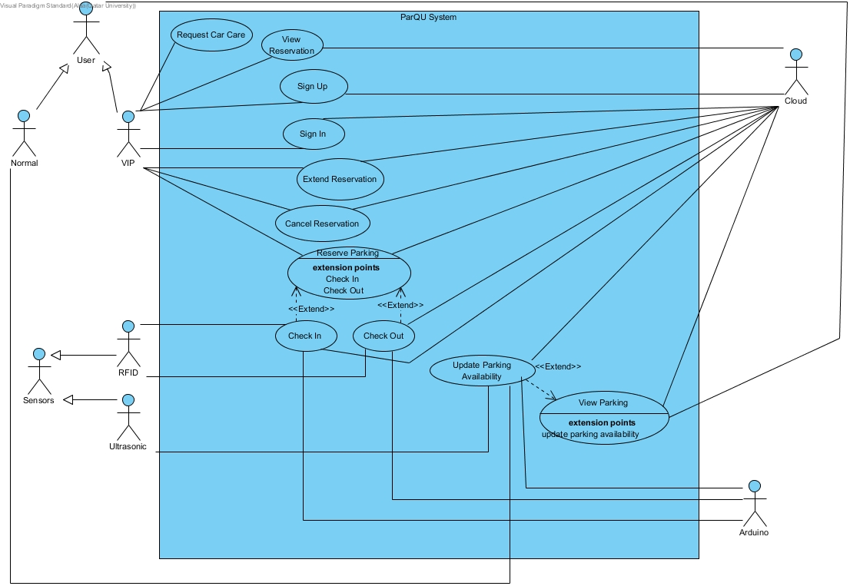

Figure ‎3‑3: Use case diagram

Table ‎3‑1: Actor type and descriptions

|  |  |
| --- | --- |
| Actor types | Description |
| VIP User | Anyone subscribed to the VIP services such as reservation service and requests car care service. |
| Normal User | Anyone who is not subscribed to the VIP services. |

Table ‎3‑2: Use cases and descriptions

|  |  |
| --- | --- |
| Use case | Brief description |
| Sign Up | VIP user registers in the system. |
| Sign In | VIP user logs into the system. |
| Reserve Parking | VIP user reserves a parking spot for several hours. |
| View Reservation | VIP user views reservation details. |
| Extend Reservation | The VIP user extends a reservation. |
| Cancel Reservation | The VIP user cancels a reservation. |
| Check In | The system reads the RFID tag on the car, checks its validity, then allows reserved VIP users only to enter the parking lot. |
| Check Out | The system reads the RFID tag on the car, checks its validity, then update available parking spots. |
| View Parking | The user views a map with the current status of parking spots. |
| Update Parking Availability | The system receives updated data from sensors through the Arduino board. |
| Request Car Care | The VIP user requests car care service which will display contact numbers of car care company. |

## Non-functional requirements

**Design constraints**

Table ‎3‑3: Technical design constraints

|  |  |
| --- | --- |
| Name | Description |
| Reliability | Data is saved at all times on the Firebase database, so no data will be lost. |
| Scalability | The system can support the addition of sensors and components as well as have more users and the cloud can be upgraded accordingly. |
| Connectivity | Firebase database needs to be connected to the internet to collect updated data from the sensors through the Arduino board. Also, the mobile application needs to be connected to the internet to get the data |
| Availability | The system should be always available. During using the application, if any data is changed in the firebase database, the application should automatically display the updates without needing to refresh the page. |
| Mobility | The system can be accessed from two different platforms: an Android application and a website |
| Power | Power source needed for:  Motor: 3-7V  Sensor: 5V  Arduino: 7-12V |

Table ‎3‑4: Practical design constraints

|  |  |  |
| --- | --- | --- |
| Type | Name | Description |
| Economics | Cost | The prototype for availability module which consists of 4 parking spots should cost 270 QR on average.  The prototype for reservation module should cost 260 QR on average. |
| Social | Usability | A normal user with minimal software knowledge should be able to use the mobile application and the website with ease |
| Sustainability | Maintenance | The system’s component should be easy to replace, remove and implement. |
| Quality | Performance | The system should provide efficient information and accurate readings from the parking area. |

**Design standards**

Table ‎3‑5: Standard types and descriptions

|  |  |
| --- | --- |
| Standard Types | Description |
| Networking Standard | HTTP (Hypertext transfer protocol) |
| Security Standard | OpenID Connect (used for delegated authentication) |
| Wireless Standard | IEEE 802.11 (Wi-Fi) |
| Serial Communication Standards | SPI (Serial Peripheral Interface) |

## Assumptions

Below are some assumptions that are beyond the scope of this project but necessary for the project to work properly:

* Arduino is always connected to the sensors.
* A power source is connected to the Arduino.
* Arduino always has a Wi-Fi connection.
* Firebase can always store data without limits.
* Application and website are always available.
* Mobile and PC that access our application and website is always connected to the internet.
* VIP user always has an RFID tag.

## Ethics

Table ‎3‑6: IEEE and ACM code of ethics

|  |  |
| --- | --- |
| Code | Project Perspective |
| IEEE  To seek, accept, and offer honest criticism of technical work, to acknowledge and correct errors, and to credit properly the contributions of others.  ACM  - Honor property rights including copyrights and patent.  - Give proper credit for intellectual property. | Any project or work used is referenced in this paper. Feedback will be accepted by the supervisor and the examiners. |
| IEEE  To treat fairly all persons and to engage in acts of discrimination based on race, religion, gender, disability, age, national origin, sexual orientation, gender identify, or gender expression.  ACM  - Be fair and take action not to discriminate. | Project members have all worked together to produce this work which can be used by all types of people. |
| IEEE  To assist colleagues and co-workers in their professional development and to support them in following this code of ethics. | The project is collaborative; every team member will work on it and ensure the code of ethics is strictly followed. |
| ACM  - Contribute to society and human well-being.  - Manage personnel and resources to design and build information systems that enhance the quality of working life. | The design aims to achieve better standards and benefits. |

## 

# References

[1] “Qatar-Education Statistics, 2013,” *Arab Development Portal*, 23-Aug-2017. [Online]. Available: http://arabdevelopmentportal.com/publication/qatar-education-statistics-2013. [Accessed: 02-Oct-2018].

[2] “About”, *Qatar University*. [Online]. Available: http://www.qu.edu.qa/about. [Accessed: 24-Nov-2018].

[3] Al-Arab, (2016). [online] Available at: http://www.alarab.qa/story/1010307. [Accessed 17 Sep. 2018].

[4] Al-Watan, (2018). [online] Available at: http://www.al-watan.com/news-details/id/156085. [Accessed 12 Oct. 2018].

[5] Al-Watan (2018). [online] Available at: http://www.al-watan.com/news-details/id/129483. [Accessed 12 Oct. 2018].

[6] S. A. Shaheen and C. Kemmerer, “Smart Parking Linked to Transit,” *Transportation Research Record: Journal of the Transportation Research Board*, vol. 2063, no. 1, pp. 73–80, 2008. [online]. Available: https://journals.sagepub.com/toc/trra/2063/1

[7] J. Chinrungrueng, U. Sunantachaikul and S. Triamlumlerd, "Smart Parking: An Application of Optical Wireless Sensor Network," *2007 International Symposium on Applications and the Internet Workshops*, Hiroshima, 2007, pp. 66-66. doi: 10.1109/SAINT-W.2007.98. available: http://ieeexplore.ieee.org/stamp/stamp.jsp?tp=&arnumber=4090136&isnumber=4090057

[8] D. Pojani, I. Mateo-Babiano, J. Corcoran, and N. Sipe, “Should we get rid of parking spaces to free up land in our cities?” *ABC News*, 06-Nov-2017. [Online]. Available: https://www.abc.net.au/news/2017-10-30/should-we-get-rid-of-car-parks-to-free-up-land-in-our-cities/9099272. [Accessed: 26-Oct-2018].

[9] D. Pojani, I. Mateo-Babiano, J. Corcoran, and N. Sipe, “Freeing up the huge areas set aside for parking can transform our cities,” *The Conversation*, 09-Nov-2018. [Online]. Available: http://theconversation.com/freeing-up-the-huge-areas-set-aside-for-parking-can-transform-our-cities-85331. [Accessed: 12-Nov-2018].

[10] INRIX, “Searching for Parking Costs Americans $73 Billion a Year - INRIXINRIX,” *INRIX*. [Online]. Available: http://inrix.com/press-releases/parking-pain-us/. [Accessed: 19-Nov-2018].

[11] Y. Rahayu and F. N. Mustapa, “A Secure Parking Reservation System Using GSM Technology,” *Int. J. Comput. Commun. Eng.*, pp. 518–520, 2013.

[12] B. Haider, M. Zafrullah, and M. K. Islam, “Radio Frequency Optimization & QoS Evaluation in Operational GSM Network,” p. 6, 2009.

[13] R. Yusnita, F. Norbaya, and N. Basharuddin, “Intelligent Parking Space Detection System Based on Image Processing,” *Int. J. Innov.*, vol. 3, no. 3, p. 4, 2012.

[14] H. Chien Yee and Y. Rahayu, “Monitoring Parking Space Availability via Zigbee Technology,” *Int. J. Future Comput. Commun.*, vol. 3, no. 6, pp. 377–380, Dec. 2014.

[15] A. Kianpisheh, N. Mustaffa, P. Limtrairut, and P. Keikhosrokiani, “Smart Parking System (SPS) Architecture Using Ultrasonic Detector,” *Int. J. Softw. Eng. Its Appl.*, vol. 6, no. 3, p. 8, 2012.

[16] A. Ahad, Z. R. Khan, and S. A. Ahmad, “Intelligent Parking System,” *World J. Eng. Technol.*, vol. 04, no. 02, pp. 160–167, 2016.

[17] R. S. Pressman, *Software engineering: a practitioner’s approach*, 7th ed. New York: McGraw-Hill Higher Education, 2010.

[18] T. Lin, H. Rivano, and F. Le Mouel, “A Survey of Smart Parking Solutions,” *IEEE Trans. Intell. Transp. Syst.*, vol. 18, no. 12, pp. 3229–3253, Dec. 2017.

[19] “What are the differences between Raspberry Pi and Arduino?” 2017. [Online]. Available: https://www.electronicshub.org/raspberry-pi-vs-arduino/. [Accessed: 24-Nov-2018].